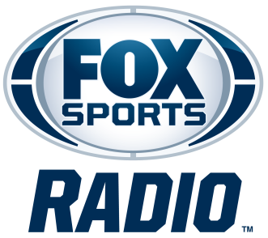

MIKE HARMON
BIOGRAPHY

Mike Harmon is co-host of FOX Sports Radio’s The Jason Smith Show with Mike Harmon, a weekday evening program featuring live, immediate reaction both during and directly after the biggest games in sports. The program can be heard on more than 480 stations nationwide from 10 p.m. – 2 a.m. ET/7 p.m. – 11 p.m. PT, in addition to FOX Sports Radio’s channel on iHeartRadio.

Partnered with Smith since 2014, they have become one of sports radio’s most entertaining and distinctive duos. Known for their quick wit, deep sports knowledge, and passionate opinions, they help break down the day’s biggest headlines while engaging listeners with a unique mix of analysis and humor.

FOX Sports Radio’s resident fantasy sports expert, Harmon also hosts weekends on the network, providing fans with comprehensive game-day previews, including betting and fantasy breakdowns.

Before joining FOX Sports Radio full time, Harmon spent eight years as a columnist and analyst for FOX Sports, covering Major League Baseball and fantasy football from 2006 to 2014. Prior to that, he spent seven years with Yahoo! Sports, where he established himself as one of the industry's leading fantasy sports voices.

Fans can follow @SwollenDome on social media.
# # #

